**CHAPTER 1 - INTRODUCTION**

**Project Introduction**

Nowadays, people are very modern and technology based. They want easy and stress less life. They do not want to stand on long queue. They used technology like mobile phone, Laptop and internet for buying products, ordering food and booking seat for travel or watch movie sin theaters on online. The proposed project “Online Movies Booking System” whereby customers can book ticket for movies in online from a multiplex web app in real time.

**1.1 Justification of Project**

**Background of Project**

Online Movie booking system is web portal where you can book movies for specific date or choose timing for movies show, watch movies trailer and read reviews. You can also view Upcoming movies.

You can also know the rate for Movies and timing just browsing for anywhere and anytime on online. You just need to register in the app and login to browse to all movies which are currently running in theaters and many more facilities. Customers can book 24 hours a day from anywhere for the around globe.

Online movies booking system is very user-friendly application where you can interact with system easily. You do not need to go for theater for booking for movies. You can track everything about movies, timing of movies just clicking it of web app on online. I have used PHP for programming and My SQL for manage database of movies.

**CHAPTER 2 – Analysis**

Analysis is the process of identification and documentation of requirement of the proposed system. In the analysis phrase, first step is to feasibility study after that we model system in use case diagram and class diagram which is also called system modelling. (SDC, 2011)

**2.1 Requirement Analysis**

|  |  |  |  |
| --- | --- | --- | --- |
| Functional and non-functional requirement | Requirement | Justification | Moscow |
| F(R1) | User Registration to system | User must registration to system. | Must have |
| F(R2) | User Login to system | User must Login to System for booking movies. | Must have |
| F(R3) | Add Movies | Admin can add movies | Must have |
| F(R4) | View Movies | User can view details of movies | Must have |
| F(R5) | View show time | User can view details of show time of movie | Must have |
| F(R6) | View show date | User can view details show date of movie | Must have |
| F(R7) | Update User profile | User can update their profile | should have |
| F(R8) | Update Movies | Admin can update movies | Must have |
| F(R9) | Ticket generate after booking Movies | Ticket must generate after user book particular movie | Must have |
| F(R10) | Seat selection | User can select seat | Must have |
| F(R11) | Show name | System must view show name | Must have |
| F(R12) | Show type | System must view show type and show time | Must have |
| F(R13) | Delete Movie | Admin can delete movie | Must have |
| F(R14) | Admin Login | Admin can login to system | Must have |
| F(R15) | Update Admin Profile | Admin can update his/her profile | Should have |
| NF(R16) | Security of system | Make sure that System must secure and protected from unauthorized access. | Must have |
| NF(R17) | Portability | System should be run in every platform. | Should have |
| NF(R18) | usability | System should navigation easily and easy to use. | Should have |
| NF(R19) | Scalability | System should store more and more information easily | Could have |
| NF(R20) | Maintainability | Maintenance should be done in regular basic | Must have |
| F(R21) | Check seat availability | Admin and user can check available seat | Must have |
| NF(R22) | Privacy | System should keep user information private | Must have |
| NF(R23) | Reliable | Precise and accurate information should given to system | Should have |

**2.2 Feasibility study**

Feasibility study is used to describe of idea which is ensuing a project which is legally and technically feasible and economically just able. It can also identify project is potentially success. For this project feasibility study is undertaken which are as below:

Interview

Advantages of feasibility study:

* It can provide valuable information for the project.
* By evaluating multiple factor, it has enhanced success rates.

Disadvantages of feasibility study:

* Costly
* Wrong information

**2.3 Use-Case Diagram**

A Use-case is a software and system engineering term that describe how user can interact with system to perform a particular operation. A use case acts as a software modelling technique that implies function to be implemented. (Techopedia, 2018)

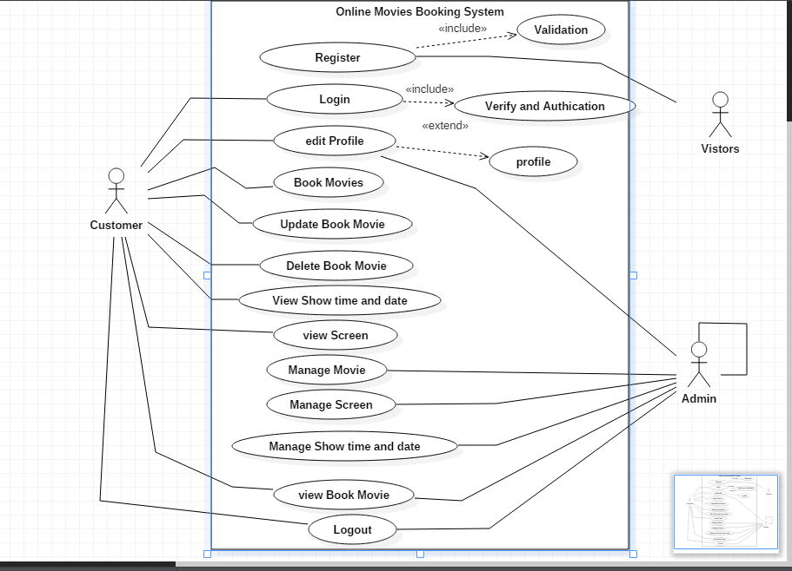

Figure 1:Use-case Diagram for Online Movies Booking

**Justification**

In above diagram, there are three types of actors i.e. first one is visitor’s who is unregister customer for the system, second one is registered customer and last one is admin who manages whole system.

First actor i.e. visitor who can registration to the system via registration script and he/she can become the registered customer. Now, he/she can do all things that registered customer can do to the system.

Second actor i.e. registered customer who is mainly focus by system. He/she can book movies, edit their profile, view different show time and date of movies running in the theaters and also update and delete book movie.

Lat actor i.e. admin who is system administration. He/she can manage movies, different shows times and dates, manages screen view book movies manages etc.

**2.4 Initial Class Diagram**

A class diagram is a description of relationship between different classes. It is a static diagram which represent static view of system. It describes the attributes and operations of class. It also shows a collection of classes, interface, association. (Guru, 2019)

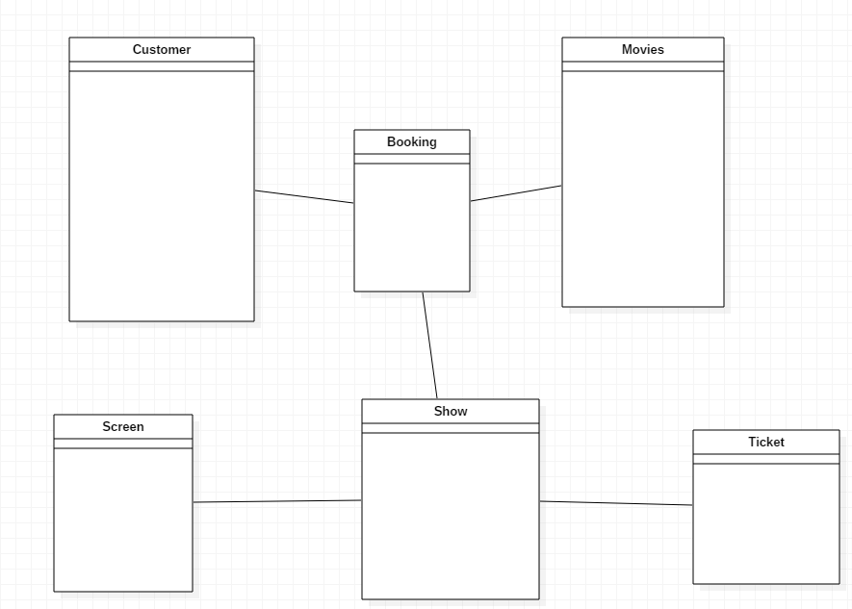

Figure 2: Initial Class Diagram

**Chapter 3: Design**

A design phrase is detailed document providing information about a going to developed product of process. Its main aims to ensure that development product should meet users’ requirements. There are three types of design phrase i.e. structural design, behavioral design and database design.

**3.1 Structural Design**

It is architectural of the system which emphasis on the class, object and method of the system.

**3.1.1 Class Diagram**

Class Diagram is UML, a type of static view of the system that describes the whole structure of the system by show classes, attributes, operation or method and relationship between classes. (Visual-Paradigm, 2019)

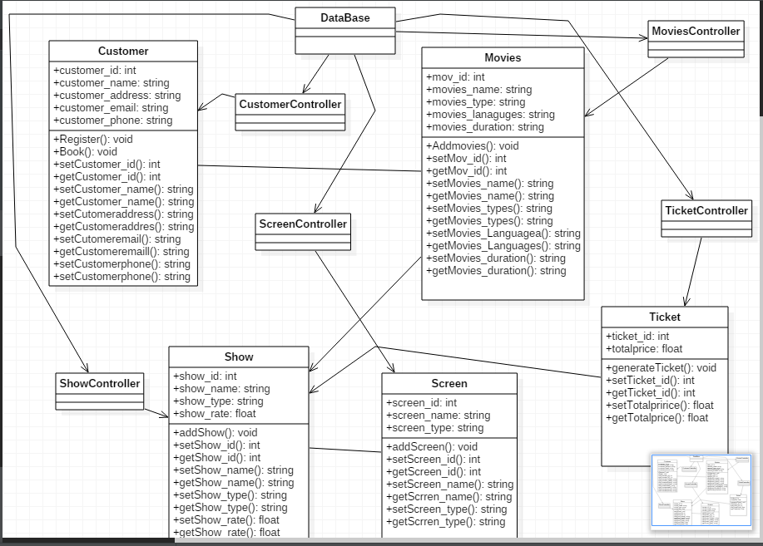

Figure 3: Final Class Diagram

**Justification**

The above class diagram illustrated that each class has each controller and controller are direct associated with Database. Ticket class is dependent with show class and ticket controller. Booking is dependent on Movies and Customer class.

**3.2 Behavioral Design**

**3.2.1 Activity Diagram**

Activity diagram is UML diagram which describes the dynamic aspect of the system. It is advanced version of flow chart which show logic of flow of one activity to another activity.

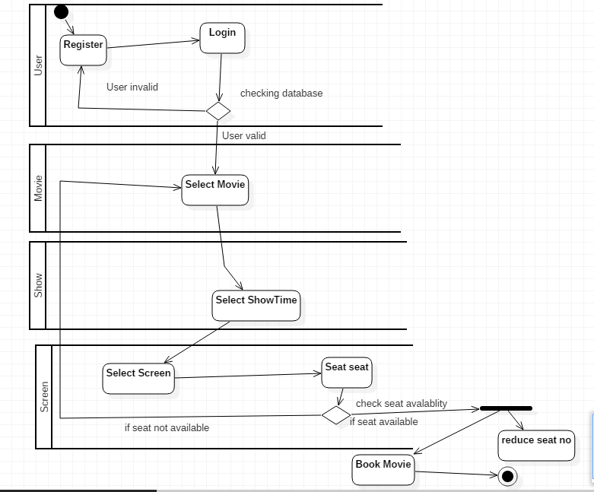

Figure 4: Activity Diagram for movies Booking

**Justification**

The above activity diagram is for booking movies for user. At first user can register and after that login in user class. If user is valid system will redirect to movies class display with movies name where user can select movies or if user is invalid system will redirect to register form. After selecting movies, now user will select show time in show class after that again select screen and seat in screen class. If seat is unavailable then system will redirect to movies list again or if seat is available two operation is performed simultaneously one is book movies and another one is reducing no of seats from particular screen.

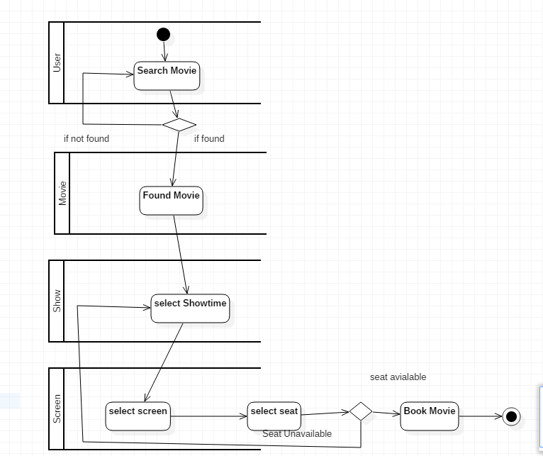

Figure : Activity diagram for search movies

**Justification**

Above activity diagram is for searching movie by the users. At first user can search movies in search after that decision is used where if movies do not find than it redirects search again or if movie found than it redirects to movies details and after that user can select show time. If showtime is available than user select screen and seat. If seat available user can book movie if not user choose next show time.

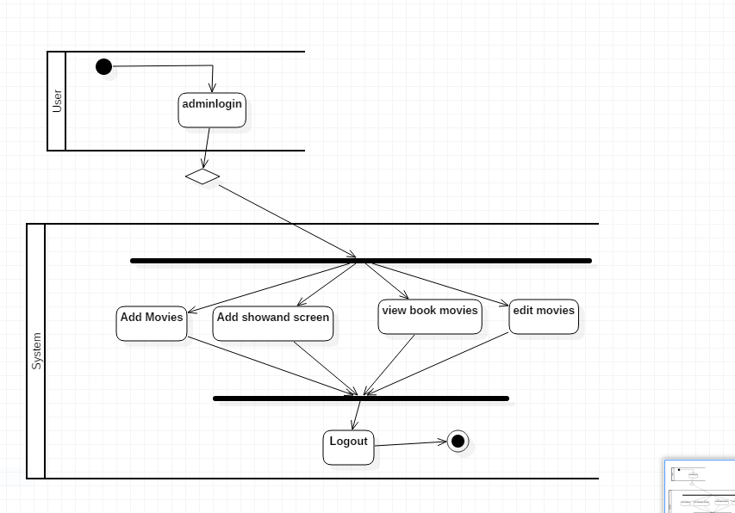

Figure : activity diagram for admin

Above activity diagram illustrated the activity done by the admin. Admin can add edit delete movies, showtime and screen. In the diagram at first admin login to system after that admin will add movies add showtime and screen view booked movie by user and edit movies.

**3.3.2 Sequence Diagram**

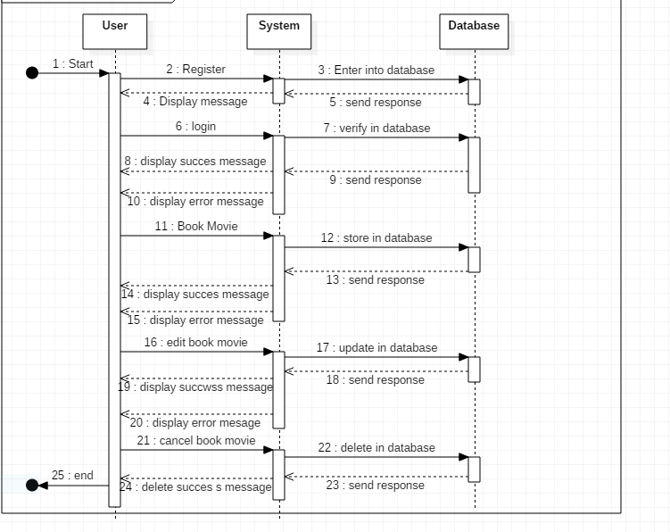

Figure : Sequence Diagram for User activity

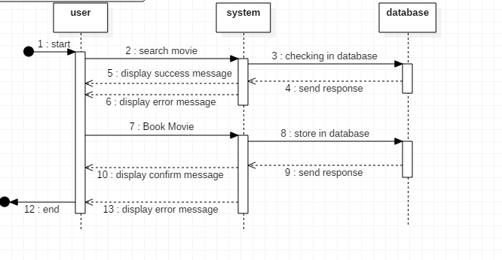

Figure :Sequence Diagram for Searching Movies

**3.3 Database Design**

Database design is the process of designing, development and implementation of data for proposed system. The main aims of database design are to produce logical and physical model for any system. (Guru, 2019)

**3.1 Entity Relationship Diagram**

An Entity Relationship Diagram also called as ERD is a type of flowchart that illustrates how entities relate with each other within system.

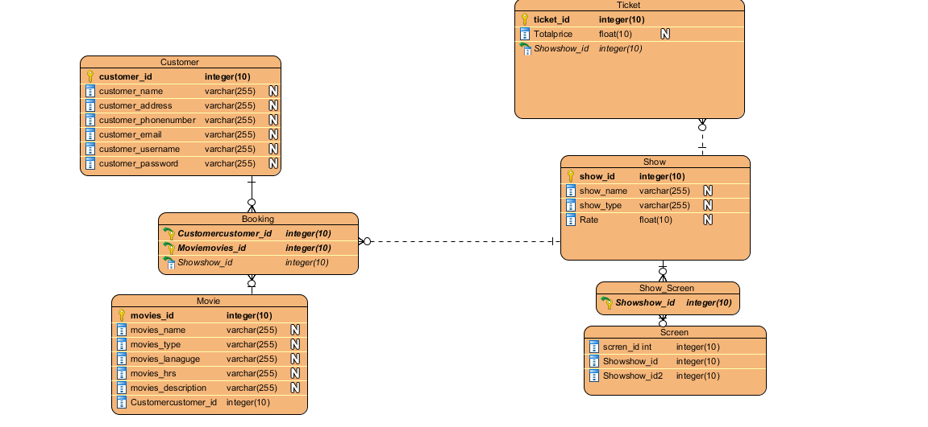

Figure 9: ER-Diagram for Online movies Booking System

**3.2 Meta-Data**

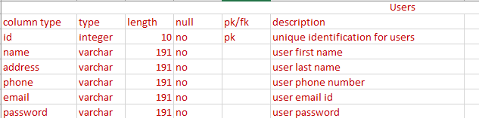

Figure 10: metadata of user

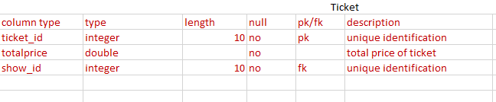

Figure 11: metadata for ticket

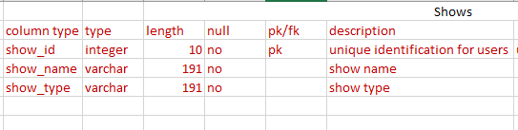

Figure 12: metadata for shows

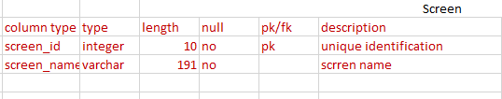

Figure 13: metadata for screen

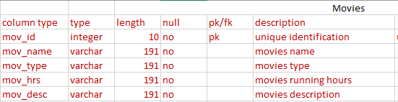

Figure 14: metadata for movies

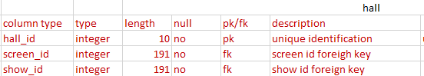

Figure 15: metadata for hall

